Stereo Headphones with integral boom Microphone
DM-N90
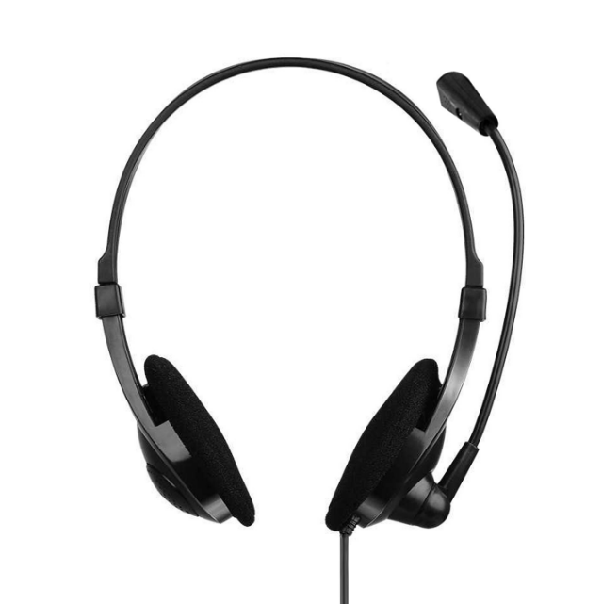

Descrption:
Superior Digital Stereo Headphones with comfort Ear-pads for prolonged use,
combined with Microphone and adjustable Volume control for trouble free communications.

Features:
  - Frequency Range: 20Hz-20KHz
  - Impedance: 32 Ohm
  - Maximum Power Input: 100mw
  - Sensitivity: 105dB S.P.L. at 1KHz+/-2%
  - Plugging: 3.5mm Stereo
  - Frequency Range: 16Hz-20KHz
  - Impedance: 2.0K0hm
  - Maximum Power Input: 04ma
  - Sensitivity: -55dB, 0dB=1V/Pa at1 Khz
  - Plugging: 3.5mm

